
MDA3044 BAHASA PENGATURCARAAN INDUSTRI
LECTURER: DR. LOY KAK CHOON
JOB INTERVIEW SIMULATOR
GROUP 9 MEMBERS:
NO. | MATRIC NO. | NAME
1
2
3
4
5

1.0 Analyze the Problem
Securing a job often hinges on interview performance, yet many candidates struggle because they lack realistic practice opportunities. Without proper preparation, applicants may underperform due to nervousness, insufficient knowledge of common questions, or weak response strategies. To solve this problem, we developed the Job Interview Simulator which is a Java-based desktop application designed to help users practice interviews in a structured way. The system allows candidates to select a specific job role, answer five randomly generated questions, and receive instant feedback with a scored evaluation based on keyword analysis and response quality. By simulating real interview scenarios, the tool helps users improve their confidence, refine their answers, and identify areas for growth in a low-stress environment. It is particularly useful for students, fresh graduates, and career switchers who need hands-on practice to enhance their interview skills before facing actual recruiters.

2.0 Online Research
Throughout the development of the Job Interview Simulator, our primary sources of guidance were AI tools like ChatGPT and Microsoft Copilot, along with educational platforms such as Grow with Google and YouTube. ChatGPT was especially helpful in explaining how to use JOptionPane effectively for collecting user input and displaying step-by-step feedback. It also clarified how to implement keyword matching for answer evaluation, which formed the basis of our scoring system to assess how closely a user's response aligned with expected answers. Microsoft Copilot provided real-time coding support directly within the code editor, offering smart suggestions and auto-completions, particularly when working with lists, random selection, and GUI components. In addition, resources from Grow with Google and various YouTube tutorials offered valuable insights into Java fundamentals, GUI design, and project structuring. These platforms helped us understand best practices and solve specific coding challenges. By leveraging a combination of these AI-driven tools and online learning resources, we accelerated development, debugged more efficiently, and ensured smooth logic flow from occupation selection to result display.
3.0 Pseudocode
START PROGRAM
IMPORT required libraries for:
- GUI dialogs for input and messages (javax.swing)
- File operations (java.io), reading/writing CSV)
- Date and time formatting (java.text)
- Random number generation and data structures (java.util)
DEFINE CONSTANT:
CSV_FILE = "interview_answers.csv"
INITIALIZE:
- random as random number generator
- occupationQuestions as empty map for storing questions by job
DEFINE CLASS: Question
PROPERTIES:
- text (string): the interview question
- keywords (list of strings): expected words in a good answer
CONSTRUCTOR:
- Set text and keywords from input
DEFINE CLASS: InterviewResponse
PROPERTIES:
- question(string): question asked
- answer(string):user’s input
- score(integer): score calculated
CONSTRUCTOR:
- Set properties from given input
FUNCTION: main
CALL loadQuestions()to load all predefined questions into the map
DISPLAY job slection dialog for the user to choose an occupation
IF no occupation is selected THEN
DISPLAY exit message
EXIT program
GET questionList for selected job
SHUFFLE questionList
INITIALIZE responseList as empty list to store InterviewResponse objects
LOOP through the first 5 questions:
DISPLAY the question to the user
GET user’s answer
IF answer is empty THEN
SET answer to "(No answer)"
score = evaluateAnswer(userAnswer, question.keywords)
response = InterviewResponse(question, userAnswer, score)
ADD response to responseList
CALL writeResponseToCSV(occupation, question.text, userAnswer)
SAVE response to CSV file
CALL showResults(responseList, occupation)
DISPLAY ("✅ Your answer has been saved to " + CSV_FILE)
FUNCTION: loadQuestions ()
FOR each occupation:
- Doctor
- Teacher
- Software engineer
- Lawyer
- Chef
- Pilot
- Architect
- Accountant
- Nurse
- Police officer
- Data analyst
- Journalist
- Psychologist
- Entrepreneur
- Marketing manager
ADD 4 predefined Question objects with:
- Interview question
- List of expected keywords
STORE in the occupationQuestions map
FUNCTION: evaluateAnswer(answer, keywords)
SET score : random number between 50 and 80
FOR EACH keyword in the list:
IF keyword is found in the answer
ADD 4 to score
RETURN score capped at 100
FUNCTION: showResults(responseList, occupation)
BUILD summary message with:
- Each question, answer, and score
- Average score
IF average score ≥ 85 THEN
DISPLAY " 🎉 Excellent! You’re a great fit for the job."
ELSE IF ≥ 70 THEN
DISPLAY " 🙂 Good job. You may need a bit more preparation."
ELSE
DISPLAY " 😬 Needs improvement. Consider brushing up before the next interview."
FUNCTION: writeResponseToCSV(occupation, question, answer)
GET current date and time
OPEN CSV file in append mode
WRITE occupation, timestamp, question, answer to file
CLOSE file
END PROGRAM
4.0 Demonstration
4.1 Main Menu
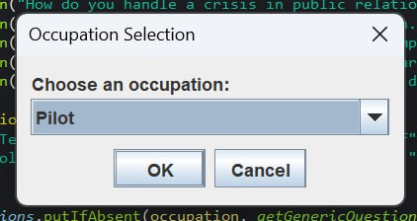
The user should click here to see more occupations and find one they are preparing to interview for.
Displayed as the user opened.

4.2 Occupation Selection
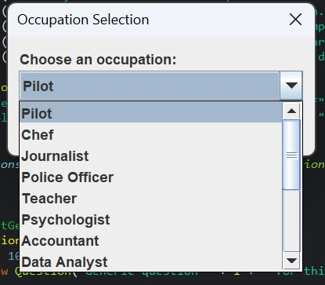
Listed here are all the occupations available in the interview simulator. The user can choose one and click 'OK' or press the Enter key.
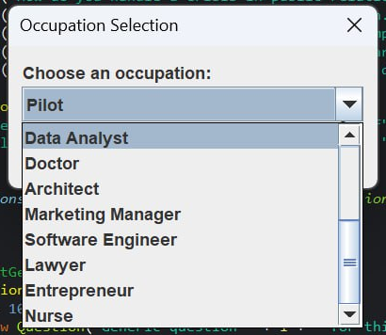
4.3 Questions and Answer
A random question will appear here, and the user must type their answer in the input field. Then, click 'OK' to move to the next question. This continues until all five questions have been completed.
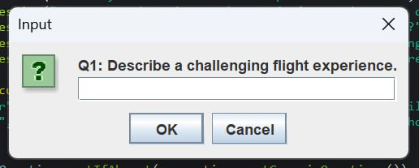

4.4 Interview Result
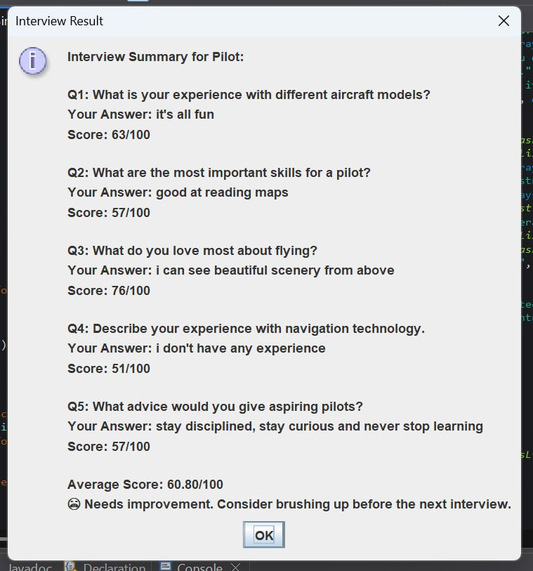
Click “OK” to end the session
The average score out of 100 is shown, along with feedback to help improve interview skills.
Question and the user’s answer followed by the score obtained for each question.
User-Selected Occupation.

4.5 Save to CSV File
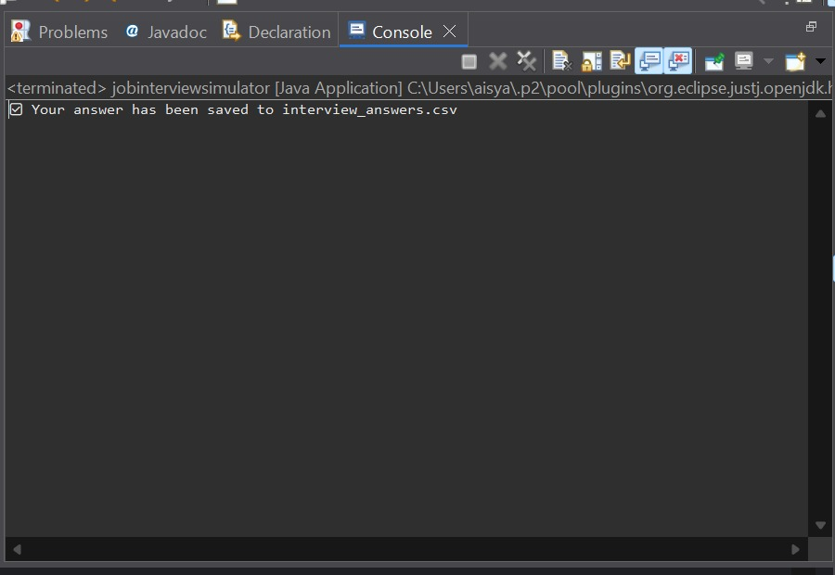
Questions and answers have been saved to 'interview_answers.csv'

4.6 Questions and Answers Review
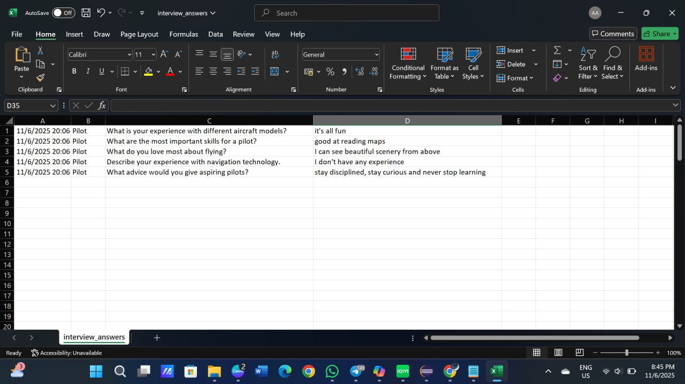
interview_answers sheet
The user can find the CSV file in their File Explorer.

5.0 References
40 Sous Chef Interview Questions (with Example Answers and What to Look For). (n.d.). https://www.cuboh.com/blog/sous-chef-interview-questions
9 questions you might be asked in a law interview | Prospects.ac.uk. (n.d.). Prospects. https://www.prospects.ac.uk/jobs-and-work-experience/job-sectors/law-sector/9-questions-you-might-be-asked-in-a-law-interview
Black, J. (2023, April 25). Doctor interview questions and answers. Medrecruit. https://medrecruit.medworld.com/articles/doctor-interview-questions-and-answers
Career Doctor, Dr Anthony Llewellyn. (2022, September 18). The Doctor Job Interview - Most common questions asked in doctor interview [Video]. YouTube. https://www.youtube.com/watch?v=CrvaUZayHHY
Common Teaching Interview Questions - Career Services - University of Maine at Farmington. (n.d.). Career Services. https://www.umf.maine.edu/careers/interviewing/common-teaching-interview-questions/
GeeksforGeeks. (2025, April 28). Java JOptionPane. GeeksforGeeks. https://www.geeksforgeeks.org/java-joptionpane/
Girardin, M. (2024, April 26). 20 Accounting Interview questions and answers. Forage. https://www.theforage.com/blog/interview-questions/accounting-interview-questions
Interview Warmup - Grow with Google. (n.d.). https://grow.google/certificates/interview-warmup/
Pilot Interview questions. (n.d.). https://careerservices.erau.edu/pilot-interview-questions
Police officer interview questions. (n.d.). https://myinterviewpractice.com/industries-details/public-safety/police-officer-interview-preparation/
Staff, C. (2025, May 21). 15 Data Analyst Interview questions and answers. Coursera. https://www.coursera.org/articles/data-analyst-interview-questions-and-answers
The 25 most common architect interview Questions. (n.d.). https://www.finalroundai.com/blog/architect-interview-questions
The 30 most common Software Engineer behavioral interview questions | Tech Interview Handbook. (2025, June 6). https://www.techinterviewhandbook.org/behavioral-interview-questions/
Wofford, P. (2024, October 3). Common nursing interview questions and how to answer them. Aspen University. https://www.aspen.edu/altitude/common-nursing-interview-questions/#0

